**Analysis – 1**

**Introduction – 1.1**

**Background**

For my NEA project I will be making a calendar that groups of people will be able to edit and put their dates and appointments into it in order to see when others are busy or not.

**Problem**

A lot of the time when you’re working or in school studying, you’ll end up having a very busy schedule and you will find that you and your friends never really have time to get together. My aim is to find an easy way to discover whether you and your friends are free for a night out or not. By creating a calendar that allows for multiple people to input their appointments and schedules all you have to do is look into the calendar and find a day where none of your friends have something planned making meeting up with your buddies exceptionally easy.

**Limitations of Current Situation**

The current limitations of existing calendars are that most will only allow for you to put your own personal dates in the calendar. You’re then left having to ask your work colleagues or friends if they’re busy or what they’re doing on a Thursday afternoon. This could be troublesome if you happen to be asking them for a date very soon and you’re dependant on their answer or if they are busy at the time of asking so you’re left waiting for them to come back to you.

**Target Audience**

My project will be aimed at all ages from teenager and above as everyone starts to use a calendar from roughly secondary school in order to stay organised and on top of work. It can be used by younger people to organize school group projects or meet ups with friends. It can also be used by older people in terms of meetings for work or lunch

**Investigation – 1.2**

**Inspiration**

**Outlook Calendar**

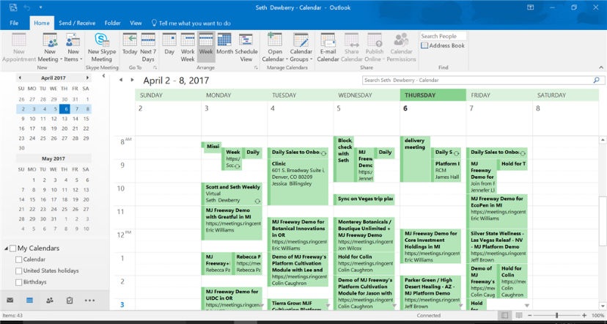

Outlook calendar is a very well-known calendar. Since a lot of people use outlook as their primary email the ease of having a calendar connected to your email appeals to a lot of people. It also has the ability to share your calendar with co-workers which is the start of becoming a group calendar but it’s not quite there. Another application is that you can create additional calendars for specific projects which influenced my idea of having separate calendar groups for things such as work, friends or school. A disadvantage of the Outlook calendar is that the GUI is close to identical with Googles Calendar showing a lack of thought in terms of the creative side of the calendar. Another disadvantage is that because the calendar for Outlook is almost like a side piece for the email it’s quite difficult to locate it from your email especially if you’re new to Outlook.

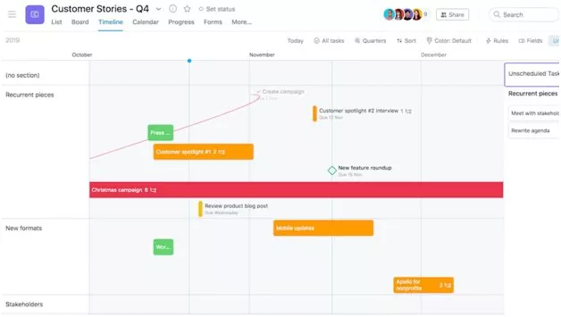**Asana**

Asana puts emphasis on collaboration and productivity, the main feature of Asana is how flexible it can really be. You can use it to keep track of ongoing work and long term projects, you can also use it to coordinate with other teams and distribute workloads among your co-workers. Asana manages to put task management, communication and other helpful tools all within a single interface which shows how useful it really is.

The unique GUI (shown in the picture) is something I want to implement into my own calendar as I want it to stand out and not fall into the group of common calendars such as Outlook or Googles calendars. While by itself Asana doesn’t have a lot of useful features built in such as time tracking or live chat it achieves a lot of functionality through app integrations.

It works with slack and Microsoft teams for live chat and Harvest for time tracking. This could be seen as a disadvantage as it has to rely on other programs other than its own for all its features. This is something that I think I can improve on as these are things that I think should be implemented into a calendar by default.

A useful part of Asana that I plan on taking inspiration from is how easy it is to manage team projects as it has a timeline feature that shows every piece of a project, how it fits together and it helps you track the changes you or your group members make. This would be extremely useful for younger people in school who sometimes leave their projects to the last minute or struggle spreading the workload between the group evenly.

**Peer Survey**

I constructed a quick survey using Google Forms, which uses a simple interface to ask users questions, it also provides a useful analytic graphic of the results.

1. 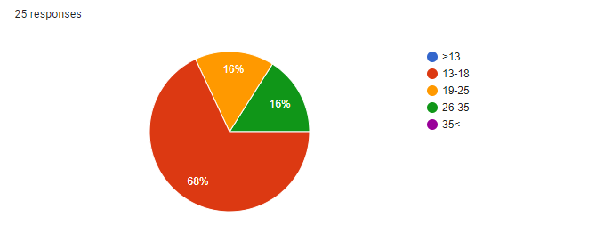What age group are you in?

With most of my participants being teenagers or young adults I can assume they will all be used to new technology and to using calendars.

1. 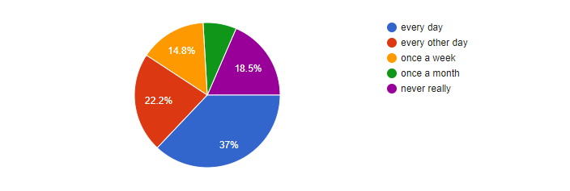How often do you use a calendar?

This question provided a reasonably wide range of answers which the majority saying they check their calendar at least every other day and the next largest group saying they used it every day which shows how vital a calendar is to the ordinary person.

1. Do you have separate calendars for your work and social?

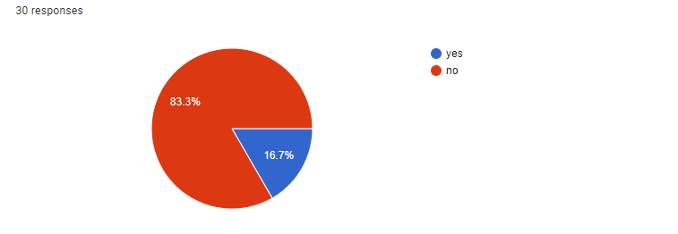I found the results for this question to be quite interesting as I’d originally thought a lot of people would have separate calendars in order to avoid clutter in their calendars. However, I’ll still need to implement a way to have separate calendars because there could be an instance where the user is working with multiple different groups and needs to have different calendars for each of the groups they are with.

1. Would you benefit from everyone in your work group or social group adding their dates onto the same calendar so everyone could see when you're busy or not?

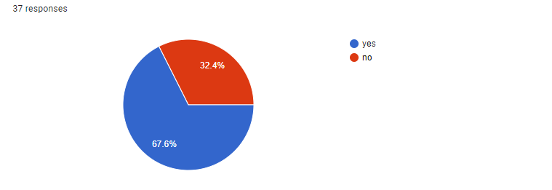Two thirds of the participants said that they would benefit from having a group calendar in order to see when their work colleagues or friends were busy which shows that there is a market for this type of thing and a lack of a group calendar out there for public use.

5)what do you normally put in your calendar?

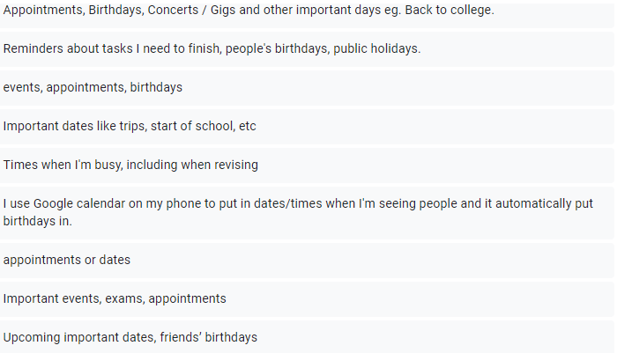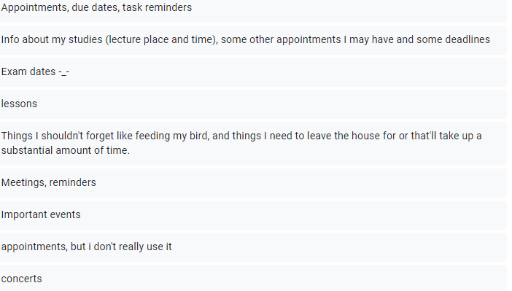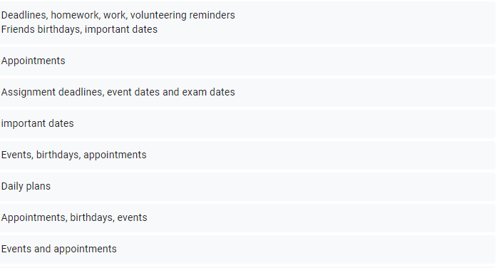With this question the participants gave a large range of answers showing the importance of a calendar as it helps remind these people of appointments, birthdays, concerts and other things that they just can’t forget about.

1. What’s the most important thing for you when it comes to calendars?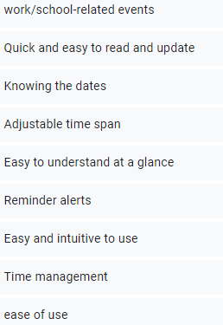

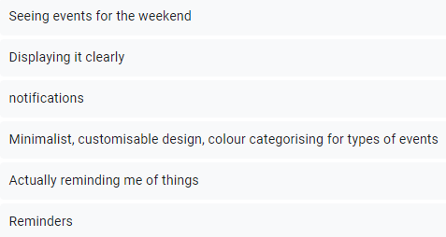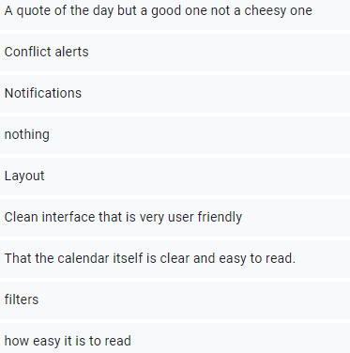

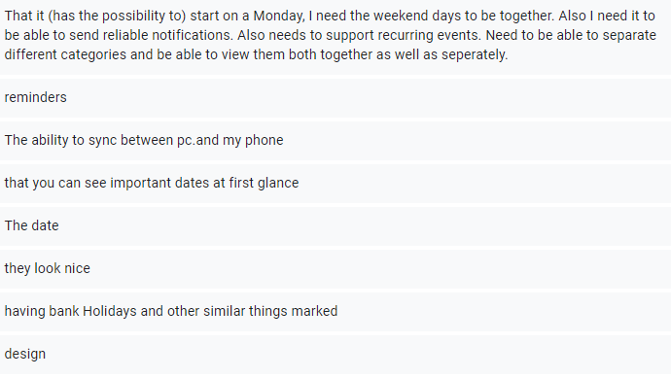

“a quote of the day” – this is an interesting suggestion and can definitely be implemented but it’s not needed for the final project.

“layout”, “clean interface”, “user friendly” – it’s very clear that a lot of the participants felt that the user interface had to be clean and user friendly which is something I was hoping to implement as I feel that the interface is a main factor in what differentiates one calendar to another.

“customisable design, colour categorising for types of events” – giving the user a choice on the background and other things lets their calendar feel more personalised and they’re more likely to enjoy using it.

“conflict alerts”, “notifications” – this is something I planned on adding. I wanted to have a notification be sent to the user if they had been invited to a event or if one of their most recent changes to their calendar had created an overlap and was now conflicting with another event.

“that you can see important dates at first” – I plan on having the user set priorities on certain events that they add to calendar that will notify the user when it’s coming close to the date in intervals (a week, 3 days, a day, etc).

7) What is something you'd like to see added to make a calendar better or more efficient?

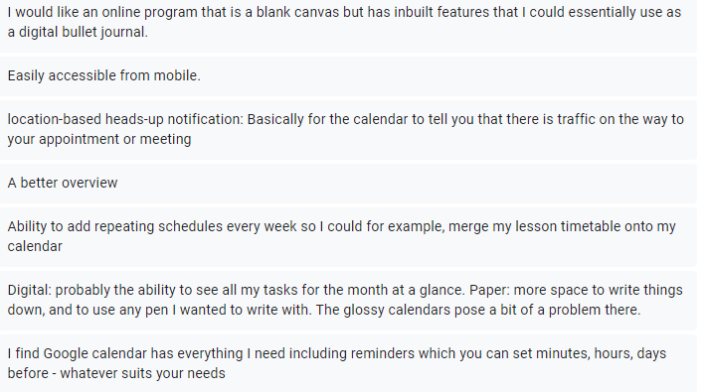

“location based heads up notification” – this is a very good suggestion but could make the project become very difficult and end up being more about this instead of the calendar.

“repeating schedules” – another good suggestion as to appeals to people who have the same timetable every week or maybe for a worker who has a meeting at the same time on the same day every week. I will definitely think about adding this as a potential feature.

“ability to see all my tasks for the month at a glance” – I plan on making the view of the calendar adjustable so you can view a day, a week, a month or a whole year if that’s your preference.

“reminders that you can set minutes, hours, days” – this is an easy feature that I’ll add which can provide a lot of use to the user.

**General Overview of my objectives – 1.3**

* Create a calendar
* Social networking aspect – profiles - groups
* Database for profiles and groups
* Have separate calendars for the user’s groups
* Notifications for invites and alerts for conflicts and when the event is coming up